RANK | EARLY & MIDDLE GRADE
- Impossible Creatures
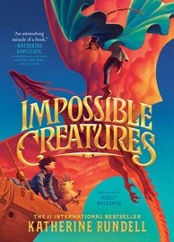



Katherine Rundell, Ashley Mackenzie (Illus.), Knopf Books for Young Readers, $19.99
- The Squad: A Graphic Novel
Christina Soontornvat, Joanna Cacao (Illus.) Graphix, $12.99
- The Bletchley Riddle
Ruta Sepetys, Steve Sheinkin, Viking Books for Young Readers, $18.99
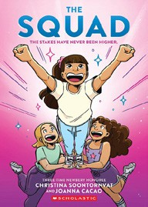

- Warriors Graphic Novel: The Prophecies Begin #1
Erin Hunter, Natalie Riess (Illus.), Sara Goetter (Illus.), HarperAlley, $15.99
- The Millicent Quibb School of Etiquette for Young Ladies of Mad Science
Kate McKinnon, Little, Brown Books for Young Readers, $17.99
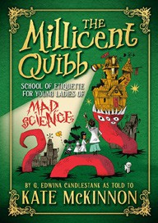

- The New Girl: A Graphic Novel
Cassandra Calin, Graphix, $12.99
- The One and Only Bob
Katherine Applegate, Patricia Castelao (Illus.), HarperCollins, $10.99
- Super Duper Extra Deluxe Essential Handbook (Pokémon)
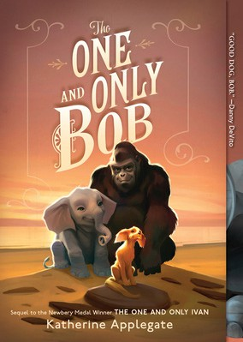

Scholastic, $16.99
- The Eyes and the Impossible
Dave Eggers, Shawn Harris (Illus.), Knopf Books for Young Readers, $19.99
- Fresh Start: A Graphic Novel
Gale Galligan, Graphix, $14.99
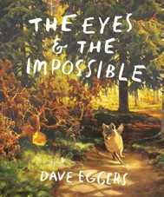

- Charlotte’s Web
E. B. White, HarperCollins, $10.99
- Scholastic Year in Sports 2025
James Buckley, Scholastic, $14.99
- Smile: A Graphic Novel
Raina Telgemeier, Graphix, $12.99
- Drama: A Graphic Novel
Raina Telgemeier, Graphix, $12.99
- Hatchet
Gary Paulsen, Simon & Schuster Books for Young
January 22, 2025
For the week ending January 19, 2025 based on sales in hundreds of independent bookstores nationwide.
CHILDREN’S

RANK | YOUNG ADULT
  - Heavenly Tyrant
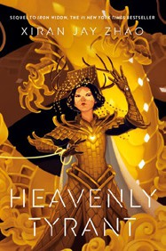

Xiran Jay Zhao, Tundra Books, $20.99
  - Powerless
Lauren Roberts, Simon & Schuster Books for Young Readers, $19.99
  - Better Than the Movies
Lynn Painter, Simon & Schuster Books for Young Readers, $12.99
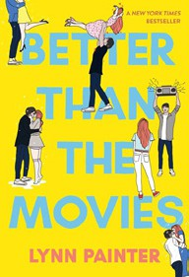

  - The Last Bookstore on Earth
Lily Braun-Arnold, Delacorte Press, $19.99
  - The Book Thief
Markus Zusak, Knopf Books for Young Readers, $14.99
  - Iron Widow
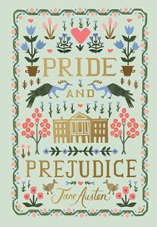

Xiran Jay Zhao, Tundra Books, $11.99
  - The Perks of Being a Wallflower
Stephen Chbosky, MTV Books, $15.99
  - Nothing Like the Movies
Lynn Painter, Simon & Schuster Books for Young Readers, $19.99
  - Reckless
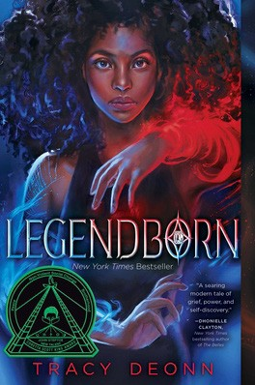

Lauren Roberts, Simon & Schuster Books for Young Readers, $21.99
  - If He Had Been with Me
Laura Nowlin, Sourcebooks Fire, $10.99
  - If Only I Had Told Her
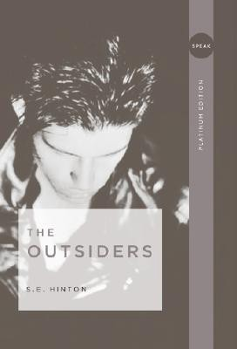

Laura Nowlin, Sourcebooks Fire, $12.99
  - Dating and Dragons
Kristy Boyce, Delacorte Romance, $12.99
  - Pride and Prejudice
Jane Austen, Anna Bond (Illus.), Puffin Books, $17
  - Legendborn
Tracy Deonn, Margaret K. McElderry Books, $13.99
  - The Outsiders
S. E. Hinton, Viking Books for Young Readers, $14.99

Readers, $9.99
OTHER CHILDREN’S INDIE FAVORITES


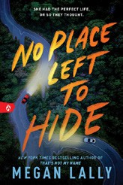

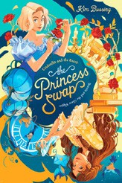

AGES 8 TO 12 TEEN READERS
Debut
Indies Introduce

Cinderella and the Beast (or, Beauty and the Glass Slipper)
Kim Bussing, Random House Books for Young Readers, $17.99 “A fun mashup of Beauty and the Beast and Cinderella that will
delight Disney fans and appeal to readers who appreciate a well-told story. Bussing brings some fun updates to these familiar stories, including a fairy godfather and a glass prosthetic.”
—Amanda Grell, Pearl’s Books, Fayetteville, AR
No Place Left to Hide
Megan Lally, Sourcebooks Fire, $12.99
“Buckle up! You’re in for a wild ride. No Place Left to Hide is a gripping thriller full of twists and turns, both figuratively and literally.”
—Alyssa Leibow, Beach Books, Seaside, OR

